ARGUS: Adaptive Real-time Green-time Update System Using Multi-Camera YOLO Vehicle Detection and PCU-Based Weighting at a Four-Leg Intersection

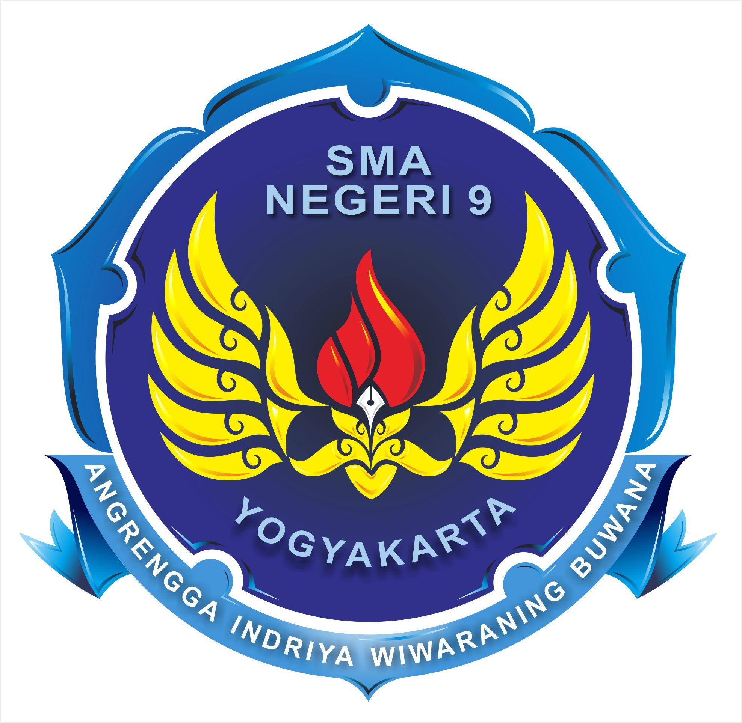

Compiled by:
Nabil Akbar Aprianto
Alvaro Arta Putra
Emir Javas Kawisworo
Baihaqi Raihan Cahyadi
Banyu Danadyaksa Karuna Gusti
Almira Aznii Azizah

SMA NEGERI 9 YOGYAKARTA

2026/2027

TABLE OF CONTENTS

TABLE OF CONTENTS 1
ABSTRACT 3
CHAPTER 1. Introduction 4
1.1. Background of the Study 4
1.2. Problem Statement 5
1.3. Objectives of the Research 5
1.4. Significance of the Research 5
1.4.1. Theoretical Significance 5
1.4.2. Practical & Applied Significance 5
1.5. Research Hypotheses 6
CHAPTER 2. Literature Review 7
2.1. Theoretical Framework 7
CHAPTER 3. Research Method 9
3.1. System Requirements Analysis and System Characteristics 9
3.1.1 System Requirements Analysis 9
3.1.2 System Characteristics 9
3.2. System Architecture and Algorithm Design 9
3.3. Software Implementation and Module Integration 10
3.4. Experimental Setup and Testing Scenarios 12
3.5. Performance Metrics and System Evaluation 13
CHAPTER 4. Results and Discussion 15
4.1. Computer Vision Testing 15
4.2. Traffic Control Evaluation 16
4.3. Emergency Vehicle Priority Testing 17
4.4. System Recovery Evaluation 17
4.5. Overall System Analysis 17
CHAPTER 5 18
Conclusion 18
References 19

ABSTRACT
Urban intersections experience changing traffic demand in which vehicle classes differ in their use of road space. Fixed-time signal plans do not directly respond to these observed variations, while emergency-vehicle prioritization requires reliable evidence before a signal phase is changed. This study presents ARGUS (Adaptive Real-time Green-time Update System), a software-based traffic-signal simulation for a four-approach intersection that combines multi-source vehicle detection, operational vehicle weighting, and dual-modal emergency-vehicle verification. The visual subsystem uses a trained YOLO26n model to detect and classify eight vehicle categories: ambulance, bus, car, fire engine, military vehicle, motorcycle, police car, and truck. Detected vehicle counts are converted into an approach-level weighted traffic score using study-defined class weights. The controller distributes a total of 120 seconds of green time among the four approaches in proportion to these scores, subject to minimum and maximum green-time bounds. The emergency-verification subsystem analyses the soundtrack of a user-selected local video. Audio is processed in three-second mono segments at 16 kHz, represented by 1,024-dimensional embeddings from pretrained YAMNet, and classified by a Logistic Regression model into ambulance, firetruck, police, and traffic categories. Emergency priority is requested only when the visual emergency-class confidence and the aggregate audio emergency score both exceed their configured thresholds on the same approach. Yellow and all-red intervals are retained during signal transitions. The study describes the system architecture, implementation, and an experimental protocol for evaluating detection, timing allocation, and emergency verification. Since ARGUS is currently a software simulation and the completed experimental results are not presented in this manuscript draft, no claim of field effectiveness or measured traffic improvement is made.
Keywords: adaptive traffic signal; YOLO26n; passenger car unit; vehicle detection; YAMNet; emergency vehicle detection; dual-modal verification.

CHAPTER 1. Introduction

Background of the Study
Rapid urbanization and escalating vehicular density pose critical challenges to modern urban mobility, directly undermining Sustainable Development Goal 11 (SDG 11: Sustainable Cities and Communities) by straining physical road infrastructure. Inefficient traffic signal control further exacerbates idling times and greenhouse gas emissions, countering SDG 13 (Climate Action). Moreover, conventional pre-timed traffic signals fail to prioritize emergency response vehicles, causing crucial transit delays that compromise public safety and emergency preparedness under SDG 3 (Good Health and Well-being).
In developing urban centers such as the Special Region of Yogyakarta, Indonesia, rapid vehicular growth exceeded 3.5 million registered units in 2025 on a largely static road network. Yogyakarta's traffic landscape is characterized by high heterogeneity, where unsegregated lanes are shared by motorcycles, private passenger cars, public transit, and heavy freight. Conventional pre-timed traffic controllers are fundamentally incapable of responding to fluctuating traffic volumes, causing clear approaches to receive unnecessary green time while congested lanes experience prolonged queuing. Furthermore, standard controllers rely on uniform vehicle counting, neglecting spatial occupancy variations between vehicle classes (e.g., motorcycles vs. heavy trucks).
These limitations are intensified by the absence of intelligent emergency vehicle preemption, leaving first responders trapped in traffic queues. Existing adaptive traffic solutions often rely on single-modal detection systems (vision-only or audio-only), which remain highly vulnerable to visual occlusions, adverse weather, or ambient urban noise.
To address these challenges, this study proposes an Intelligent Transportation System (ITS) framework named ARGUS, replacing rigid fixed-time controllers with a computer vision-driven adaptive signal allocation model powered by a fine-tuned YOLO26n object detection network. The system applies dynamic Passenger Car Unit (PCU) weighting across eight vehicle classes to compute spatial occupancy, allocating bounded green durations to prevent lane starvation. Additionally, a dual-modal verification framework combining visual recognition with YAMNet audio embeddings and complementary Mel-Frequency Cepstral Coefficients (MFCC) acoustic feature extraction enables reliable emergency preemption with a time-compensation mechanism. Finally, this research evaluates detection accuracy, signal transition latency, and green time distribution fairness across density scenarios via a scaled intersection prototype.

Problem Statement
- How can a vehicle-weighting model based on the Passenger Car Unit (PCU) concept be applied to heterogeneous traffic to calculate approach-level traffic demand and allocate green time under normal operating conditions?
- How does the signal-transition mechanism operate when the simulation grants emergency priority and subsequently returns to normal adaptive operation?
- How does the integration of visual vehicle detection and audio classification perform in verifying emergency vehicles, and how does the resulting priority request affect green-time allocation among the four approaches in the software simulation?

Objectives of the Research
- To implement a PCU-concept-based vehicle-weighting calculation for heterogeneous traffic and use the resulting approach-level scores to allocate bounded green-light durations.
- To implement and evaluate the signal transitions during emergency-priority requests and the return to normal adaptive operation.
- To integrate visual vehicle detection and audio classification for emergency-vehicle verification, and evaluate its effect on simulated green-time allocation among the four approaches.

Significance of the Research

Theoretical Significance
- Advancement in Heterogeneous Traffic Modeling: Contributes to the field of Intelligent Transportation Systems (ITS) by establishing an algorithmic model that accounts for multi-class, non-homogeneous traffic flow (varying vehicle ratios like motorcycles vs. cars) rather than relying on uniform vehicle count logic
- Integration of Vision-Based Computer Vision and Real-Time Preemption Logic: Enriches the literature on computer vision applications by combining real-time spatial object detection (YOLO) with dynamic priority override algorithms for emergency vehicles.
- Framework for Low-Cost Computational Traffic Control Systems: Provides a theoretical benchmark for executing real-time vision-based traffic algorithms on budget-friendly hardware without relying on high-cost computational infrastructure or complex machine learning models.

Practical & Applied Significance
- Reduction of Urban Traffic Congestion and Idling Time: Minimizes unnecessary vehicle waiting times by dynamically allocating green light durations based on actual road volume weight (), improving overall intersection throughput.
- Cost-Effective Infrastructure Retrofitting for Local Municipalities: Offers a scalable, budget-friendly solution for city traffic authorities to upgrade existing traffic light infrastructure without requiring expensive sensor overhauls.
- Optimization of Emergency Response Times: Drastically reduces transit delays for emergency vehicles (ambulances, police cars, fire trucks) by automatically creating an uninterrupted “Green Wave” corridor at intersections.

Research Hypotheses
The primary detection hypothesis is formulated as follows:
- H0 (Null Hypothesis):
Under the defined test conditions, the YOLO26n model does not meet the predetermined vehicle-detection performance criterion.
- Ha (Alternative Hypothesis):
Under the defined test conditions, the YOLO26n model meets the predetermined vehicle-detection performance criterion.
The selected detection metric, acceptance criterion, test dataset, and evaluation procedure must be specified before statistical analysis. The hypothesis should not be interpreted as proof of reduced traffic delay or emergency travel time.

CHAPTER 2. Literature Review

Theoretical Framework
    - Traffic Flow Dynamics and Heterogeneous Characteristics
Traffic flow at signalized intersections is described by volume, speed, and density [5]. Yogyakarta traffic is heterogeneous and includes a substantial proportion of motorcycles [6]. Because vehicle classes occupy different amounts of road space, vehicle counts alone may not represent traffic demand adequately [1]. The Passenger Car Unit (PCU) concept expresses mixed vehicle classes as equivalent passenger-car units. PCU values vary with vehicle and road conditions; the original simplified reference values are retained in Table 2.1 [7].

Vehicle Classification | PCU Value () | Reference Standard
Motorcycle (MC) | 0.25 / 0.33 | MKJI / Sugiarto et al. [7] (Simplified)
Light Vehicle / Passenger Car (LV) | 1.00 | Baseline standard [7]
Medium Heavy Vehicle / Bus (MHV) | 2.00 | MKJI / Sugiarto et al. [7] (Simplified)
Heavy Vehicle / Large Truck (HV) | 2.00 | MKJI / Sugiarto et al. [7] (Simplified)
Table 2.1: Passenger Car Unit (PCU) equivalent factors for heterogeneous traffic.

A study in motorcycle-dominated Banda Aceh traffic reported values of 0.24 for motorcycles and 1.00 for passenger cars, illustrating that PCU values are context-dependent [7]. Table 2.1 is a theoretical reference, not a direct mapping of all ARGUS detector classes. ARGUS uses separate operational weights, specified in Chapter 3.
The weighted approach score is:

where is the detected count of class on approach and is its assigned weight. This score estimates weighted demand; it does not directly measure queue length or density [3, 4].
    - Computer Vision
Computer vision detects and classifies road users from camera images and is widely applied in intelligent traffic systems [5, 20]. ARGUS uses a trained YOLO26n model to detect eight vehicle classes. Detection may be affected by lighting, camera angle, image quality, and occlusion; therefore, performance must be evaluated against labelled test data rather than confidence scores alone [17].
    - Acoustic Signals
Sirens provide an additional cue for emergency-vehicle identification, complementing visual detection when vehicles are occluded. Previous studies have investigated acoustic and audio-visual emergency-vehicle detection [8–12]. ARGUS uses pretrained YAMNet embeddings and a Logistic Regression classifier to classify audio as ambulance, firetruck, police, or traffic [27]. Its emergency audio score combines the three emergency-class scores. Audio is analysed from the soundtrack of a user-selected local video in three-second mono segments at 16 kHz.
    - Control Algorithm
Fixed-time control follows predetermined signal plans, whereas adaptive control adjusts timing to observed demand [2–5, 14]. Emergency preemption requires safe phase transitions rather than an immediate right-of-way change [23, 24].
ARGUS allocates 120 seconds of green time across four approaches. Each receives at least 10 seconds, with a maximum of 40 seconds; the remaining time is distributed according to weighted approach scores using a water-filling procedure. Capped shares are redistributed, and zero-demand cases receive equal allocation:
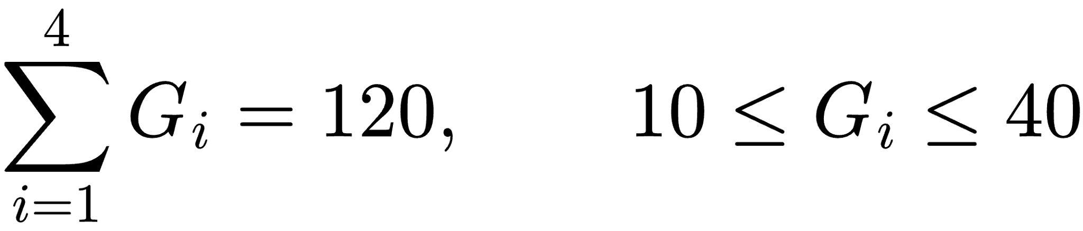
Each approach is followed by 3 seconds of yellow and 1 second of all-red, giving a nominal normal rotation of:
Emergency priority is requested only when visual emergency confidence and the aggregate audio emergency score both exceed 0.65 on the same approach:
The thresholds are software settings, and the signal retains its yellow and all-red clearance intervals.

CHAPTER 3. Research Method

System Requirements Analysis and System Characteristics
System Requirements Analysis and Characteristics ARGUS (Adaptive Real-time Green-time Update System) is a computer vision based system that is developed to optimize traffic signal timing based on real-time traffic conditions. Previous studies have explored computer vision based vehicle detection and adaptive traffic signal control [1, 3]. ARGUS use YOLO26n for vehicle detection using multiple CCTV feeds and webcams, Passenger Car Unit (PCU) for weighting and to estimate traffic load [7], and an emergency vehicle prioritization mechanism based on siren detection.

3.1.1 System Requirements Analysis
ARGUS requires integration with Yogyakarta CCTV feeds as visual data sources and webcams for experimental testing, alongside the YOLO26n model to detect and count vehicles across multiple approaches of a four-leg intersection. The detection results are processed using PCU weighting to estimate traffic load and compare conditions across approaches [2, 7]. This analysis serves as a basis for adjusting green light durations while maintaining appropriate safety constraints. Furthermore, the system requires a siren detection mechanism to prioritize emergency vehicles, as well as real-time processing capabilities, operational reliability, software compatibility, and an interface that presents traffic information clearly.

3.1.2 System Characteristics
ARGUS is characterized by computer vision based vehicle detection using YOLO26n and multi camera monitoring to achieved traffic information from different intersection [1, 2]. The system applies PCU weighting to estimate traffic load based on vehicle categories, including motorcycles, passenger cars, buses, and trucks [7]. The result estimates support adaptive green-light timing adjustments according to observed traffic conditions [2, 4]. Additionally, ARGUS incorporates an emergency vehicle prioritization mechanism based on siren detection and uses Yogyakarta CCTV feeds and webcams as visual data sources.

System Architecture and Algorithm Design
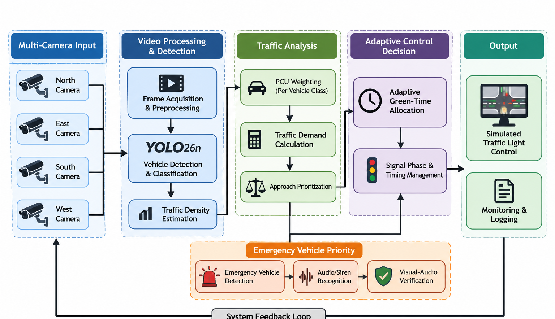
The software architecture of the ARGUS system integrates core processing modules within a Python-based environment. Vehicle detection is executed via a trained YOLO26n model utilizing the Ultralytics framework and OpenCV, targeting eight distinct vehicle classes (ambulance, bus, car, fire engine, military vehicle, motorcycle, police car, and truck) with a confidence threshold of 0.15 and an NMS IoU of 0.60. A five-frame median filter is applied to stabilize detection counts against short-term noise. Simultaneously, audio classification is performed using pretrained YAMNet embeddings combined with a Logistic Regression classifier, processing 3-second mono audio segments extracted from the soundtrack of a user-selected local video at a 16 kHz sampling rate. The resulting emergency scores quantify acoustic signals for dual-modal verification.
Traffic-load estimation maps the detected vehicle counts to operational weights to compute a cumulative traffic score for each approach. These scores govern adaptive green-time allocation within a 120-second total cycle budget, enforcing bounded durations between 10 and 40 seconds per approach, or dividing time equally under zero demand. Signal transitions incorporate a 3-second yellow interval and a 1-second all-red clearance phase, while emergency preemption is triggered when both visual detection confidence and aggregate audio emergency scores exceed the configured 0.65 threshold on the same approach. Operator monitoring and experimental data logging are handled through a CustomTkinter graphical user interface, which displays real-time video feeds, detection statistics, signal phases, countdown timers, and audio confidence metrics while supporting periodic system snapshot exports in CSV format for subsequent quantitative evaluation.

Software Implementation and Module Integration
    - Software Implementation
The software architecture of the ARGUS system integrates core processing modules within a Python-based environment. Vehicle detection is executed via a trained YOLO26n model utilizing the Ultralytics framework and OpenCV, targeting eight distinct vehicle classes (ambulance, bus, car, fire engine, military vehicle, motorcycle, police car, and truck) with a confidence threshold of 0.15 and an NMS IoU of 0.60. A five-frame median filter is applied to stabilize detection counts against short-term noise. Simultaneously, audio classification is performed using pretrained YAMNet embeddings combined with a Logistic Regression classifier, processing 3-second mono audio segments extracted from the soundtrack of a user-selected local video at a 16 kHz sampling rate. The resulting emergency scores quantify acoustic signals for dual-modal verification.
Traffic-load estimation maps the detected vehicle counts to operational weights to compute a cumulative traffic score for each approach. These scores govern adaptive green-time allocation within a 120-second total cycle budget, enforcing bounded durations between 10 and 40 seconds per approach, or dividing time equally under zero demand. Signal transitions incorporate a 3-second yellow interval and a 1-second all-red clearance phase, while emergency preemption is triggered when both visual detection confidence and aggregate audio emergency scores exceed the configured 0.65 threshold on the same approach. Operator monitoring and experimental data logging are handled through a CustomTkinter graphical user interface, which displays real-time video feeds, detection statistics, signal phases, countdown timers, and audio confidence metrics while supporting periodic system snapshot exports in CSV format for subsequent quantitative evaluation.
    - Module Integration
The ARGUS modules are integrated through two primary processing pipelines: visual detection and audio classification. The visual pipeline processes camera feeds using YOLO26n to obtain vehicle classifications and counts, which are subsequently transferred to the traffic-load estimation module. Meanwhile, the audio pipeline processes video soundtracks using YAMNet and Logistic Regression to generate emergency classification scores.
Both outputs are connected through a dual-modal verification mechanism. When visual and audio confidence scores exceed their respective thresholds on the same approach, the system assigns emergency priority to that approach for the next green-light phase. The transition maintains the yellow and all-red intervals before granting the next green signal. Otherwise, the simulation continues using the traffic-load-based signal allocation.
All processing results are displayed through the graphical interface, while separate execution threads handle camera processing and audio analysis to maintain interface responsiveness. Research data are recorded periodically and exported in CSV format. At the current development stage, ARGUS operates as a software-based traffic simulation and has not yet been connected to physical traffic signal controllers.

Experimental Setup and Testing Scenarios
    - Simulation Environment & Configuration
The test environment represents four approaches: North, East, South, and West. For each test, record the video source assigned to each approach, computer specifications, operating system, Python and package versions, YOLO26n checkpoint, and GUI settings. For audio tests, also record the selected local video and its assigned approach.
    - Heterogeneous Traffic Density & PCU Weighting Protocol
Prepare low-, medium-, and high-demand scenarios with known vehicle counts and different class compositions. Calculate the expected approach scores manually using Table 3.1, then compare them with the scores displayed by ARGUS. Record the four green durations and verify that each is between 10 and 40 seconds and that their sum is 120 seconds. Include an all-zero-demand scenario to verify equal allocation.
    - Dual-Modal Emergency Vehicle Preemption Protocol
Prepare positive and negative cases for ambulance, fire-engine, and police-vehicle detection. Include cases where both modalities indicate an emergency, only the visual modality exceeds its threshold, only the audio modality exceeds its threshold, and neither modality exceeds its threshold. Record the approach, visual confidence, audio emergency score, and verification decision. A positive decision requires both scores to be strictly greater than 0.65 on the same approach.
    - Transition Mechanism & Time-Compensation Validation
Record the phase sequence and duration during normal operation and after an emergency-priority request. In a normal rotation, the configured duration is 120 seconds of green allocation plus four yellow intervals of 3 seconds and four all-red intervals of 1 second:
The code also calculates an adjusted approach score for selecting among simultaneously confirmed emergency candidates:

where  is the elapsed time since that approach last received green. This term is used in candidate ranking; it is not an algorithm that restores missed green time or proves that traffic queues return to equilibrium. Record the selected approach and verify that the yellow and all-red intervals are retained.
    - Environmental Robustness & Signal Degradation Testing
If robustness is evaluated, test lighting variation, camera angle, partial occlusion, image quality, and audio background noise as separate conditions. Record the conditions and corresponding detection or classification outputs. Do not claim robustness for conditions that were not included in the test data.

Performance Metrics and System Evaluation
    - Computer Vision & Object Detection Metrics
Evaluate YOLO26n using Precision, Recall, F1-score, and mean Average Precision (mAP). Determine true positives, false positives, and false negatives against labelled ground-truth annotations. The metrics are calculated as follows:

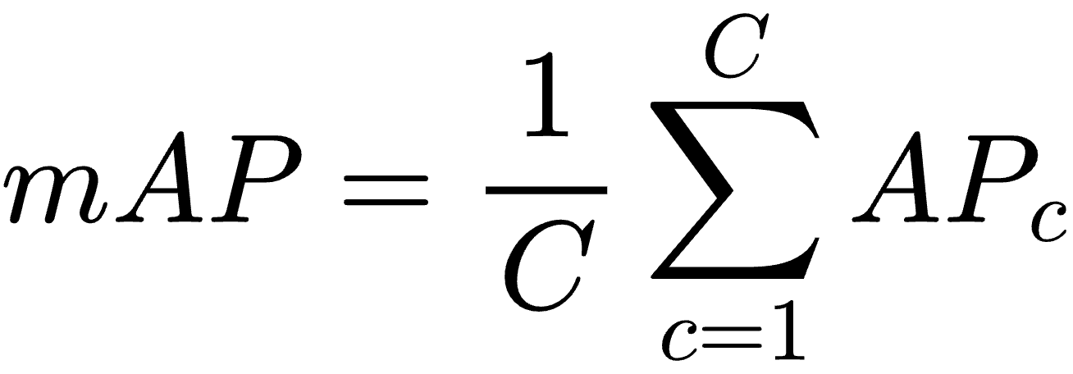
where TP is true positive, FP is false positive, FN is false negative, AP is average precision for a class, and C is the number of evaluated classes. Report per-class results and state the IoU convention; where available, include mAP50 and mAP50–95. The IoU thresholds used to calculate each mAP variant must be stated.
    - Traffic Flow & Queue Reduction Metrics
Compare ARGUS weighted scores with manually calculated scores from known vehicle counts and Table 3.1. For signal allocation, report each approach's green duration and verify the total allocation and per-approach limits:
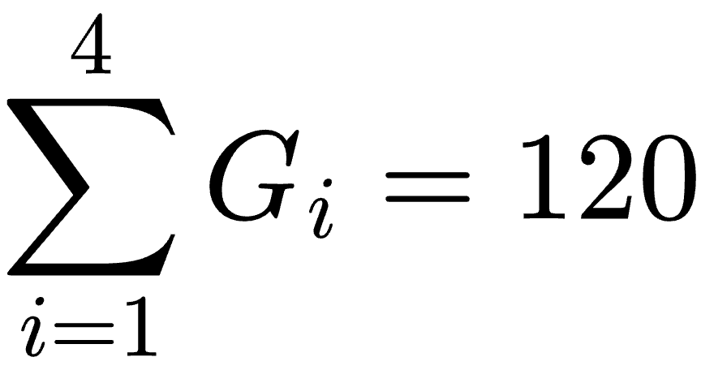 
where is the green duration, in seconds, assigned to approach . Queue length, average delay, throughput, and waiting-time improvement require a defined traffic-flow model or physical measurements and a baseline; they cannot be concluded from detection counts alone.
    - Preemption Latency & Dual-Modal Verification Accuracy
Evaluate the dual-modal decision using a confusion matrix, Precision, Recall, F1-score, false-positive rate, and false-negative rate. Calculate Precision, Recall, and F1-score using the equations in Section 3.5.1. The additional error rates are:

where TN is true negative. Report the visual and audio scores separately and identify whether both thresholds were exceeded on the same approach. Define response time consistently, for example from the start of the relevant input segment to the verification decision.
    - Signal Recovery & Transition Equilibrium
Measure the yellow and all-red durations and compare them with the configured values of 3 seconds and 1 second. The absolute duration deviation can be calculated as:
A zero deviation indicates that the measured interval matches its configured duration. Record the phase sequence during normal operation and emergency-priority requests. Any claim about recovery time, restored traffic equilibrium, or reduced delay requires a separate recovery definition and supporting measurements.

CHAPTER 4. Results and Discussion

Computer Vision Testing
Hasil deteksi kendaraan dan metrik akurasi YOLO26n
The YOLO26n model underwent 100 epochs of continued training using an image size of 640 × 640, a batch size of 16, the AdamW optimizer, and an initial learning rate of 0.000833 on an NVIDIA Tesla T4 GPU. The dataset comprised 7,596 images across eight vehicle classes, with 6,077 training images and 1,519 validation images.
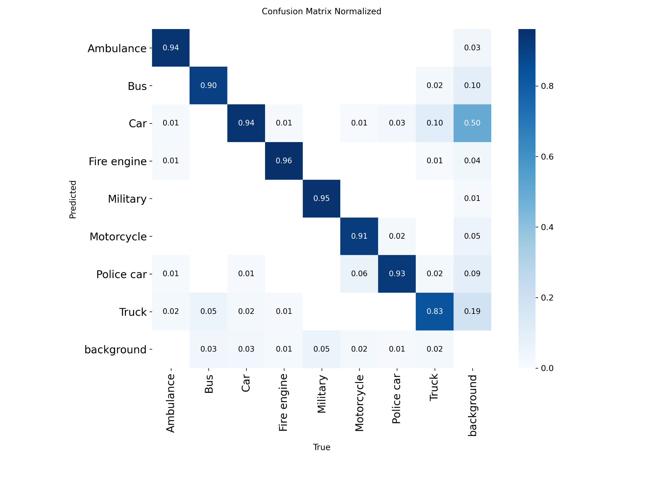  Figure 4.1. Training and validation results. | 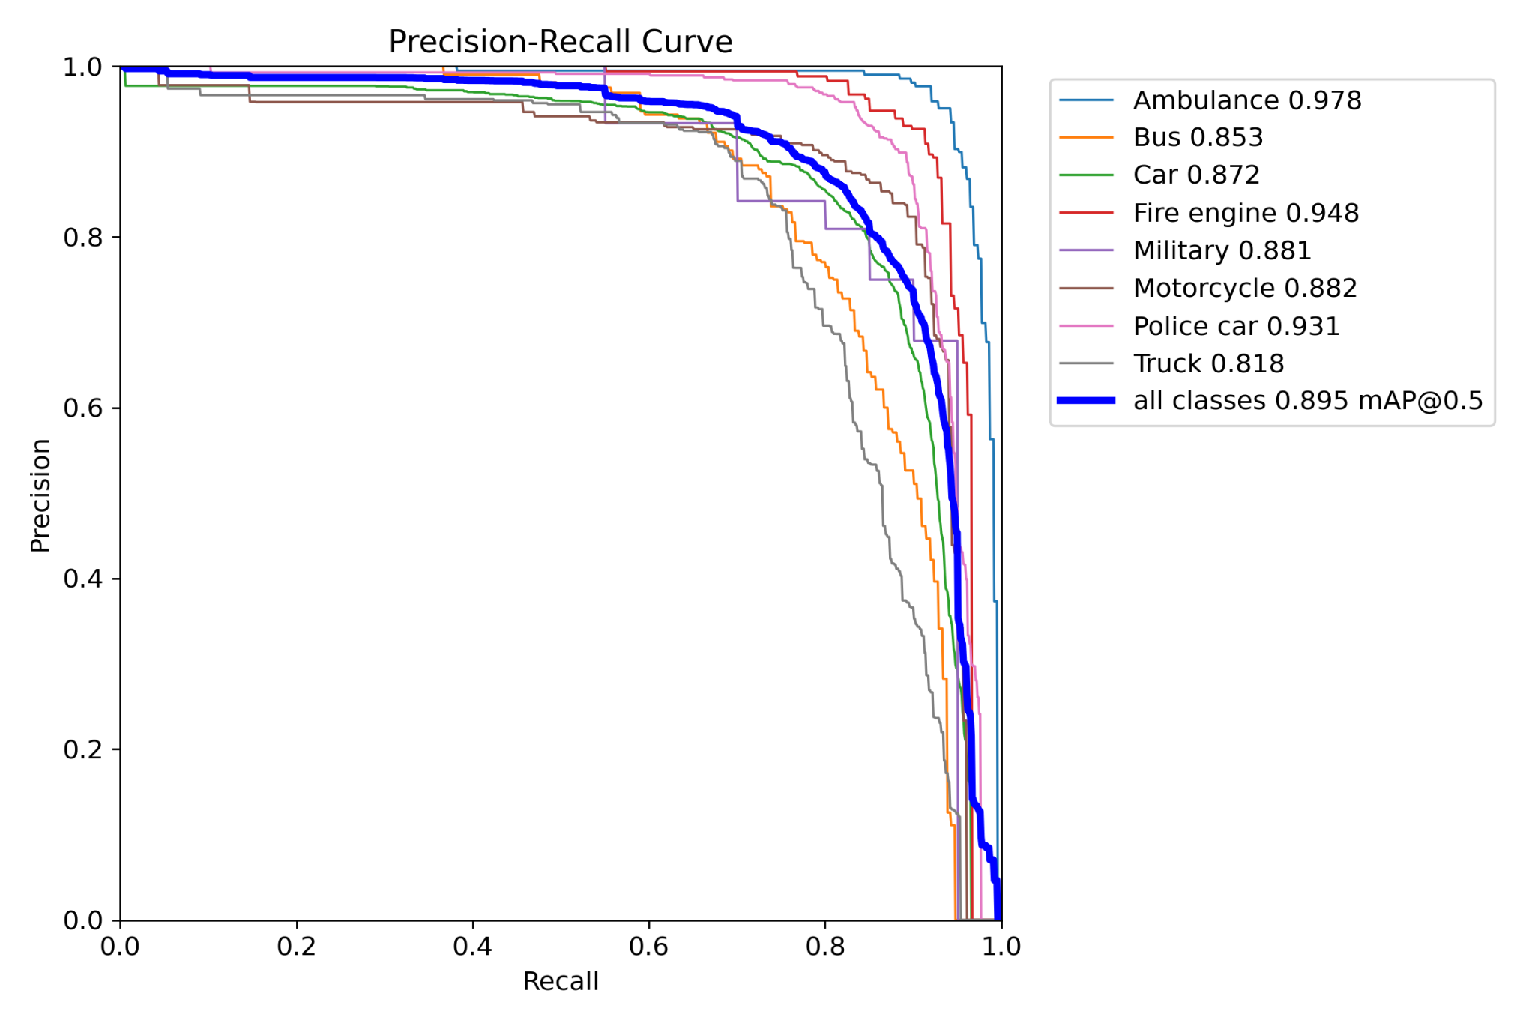  Figure 4.2. Normalized confusion matrix.
Training losses generally decreased, while detection metrics improved and later stabilized. However, validation classification loss reached its minimum around epoch 60 before increasing toward epoch 100. The normalized confusion matrix shows diagonal values of 0.94, 0.90, 0.94, 0.96, 0.95, 0.91, 0.93, and 0.83 for Ambulance, Bus, Car, Fire engine, Military, Motorcycle, Police car, and Truck, respectively. These values represent normalized matrix entries and should not be directly equated with the Recall results below.
The best-checkpoint summary reported 87.3% Precision, 83.3% Recall, 89.5% mAP@50, and 72.1% mAP@50--95. Per-class results are presented in Table 4.1.

Vehicle class | Precision | Recall | mAP@50 | mAP@50--95
Ambulance | 97.6 | 91.1 | 97.8 | 89.0
Bus | 88.2 | 71.4 | 85.3 | 66.5
Car | 84.2 | 81.4 | 87.2 | 67.4
Fire engine | 92.7 | 89.9 | 94.8 | 81.2
Military | 71.8 | 90.0 | 88.1 | 65.6
Motorcycle | 90.1 | 79.3 | 88.2 | 60.4
Police car | 89.7 | 89.2 | 93.1 | 80.8
Truck | 83.9 | 73.9 | 81.8 | 66.3
Table 4.1. Per-class validation performance (%) (Source: Author's GitHub repository, https://github.com/Varoo0jpg/Lampiu.git ).

Ambulance achieved the highest mAP@50--95 (89.0%), while Motorcycle recorded the lowest (60.4%). Bus and Truck also showed comparatively lower Recall. Military results require caution because only 20 validation instances were available. These results demonstrate vehicle-detection performance on the validation dataset, not independently verified improvements in real-world traffic flow or signal-control efficiency.

Traffic Control Evaluation
The traffic control evaluation was conducted to assess the PCU-based vehicle load estimation and green-time allocation across the four approaches. The test used data recorded in banyu5.csv. The analysis focused on one complete traffic signal cycle, from 17:12:42 to 17:14:58.

4.2.1. PCU-Based Traffic Load Estimation
The system calculates the PCU score by multiplying the number of detected vehicles in each category by their respective weights. The resulting scores represent the estimated traffic load for each approach and serve as the basis for green-time allocation.
At the beginning of the observed cycle, at 17:12:42, the system recorded the following PCU scores:

Approach | PCU Score
North | 15.64
East | 16.98
South | 3.00
West | 2.66

The results show that the East approach had the highest PCU score, followed by North, South, and West. These differences reflect variations in the number and types of vehicles detected at each approach.

4.2.2. Adaptive Green-Time Allocation
The calculated PCU scores were used to distribute a total of 120 seconds of green time. Each approach had a minimum allocation of 10 seconds and a maximum allocation of 40 seconds. The resulting allocation during the observed cycle is presented below.

Approach | Green Duration
North | 40 seconds
East | 40 seconds
South | 21 seconds
West | 19 seconds
Total | 120 seconds

The North and East approaches received the maximum green duration because they had the highest PCU scores. Meanwhile, the South and West approaches received shorter durations according to their respective scores. The total allocation remained 120 seconds, consistent with the system's configured green-time cycle.

4.2.3. Cycle-Based PCU Update Evaluation
The recorded data also show that the system updates PCU scores at the beginning of each cycle rather than recalculating them every second. For example, the North approach had a PCU score of 15.64 at 17:12:42. Although the detected vehicle counts changed by 17:13:25, its recorded PCU score remained 15.64.
The same PCU scores were maintained throughout the observed cycle, including when the green signal moved between approaches. The system updated the scores when a new cycle began at 17:14:59. The new scores were 7.00 for North, 17.31 for East, 7.65 for South, and 2.00 for West.
These results indicate that the system uses PCU scores calculated at the beginning of each cycle as the basis for green-time allocation throughout that cycle. Vehicle counts continue to be recorded periodically, but changes in those counts only affect the green-time allocation in the following cycle. Therefore, the traffic control system applies a cycle-based adaptive mechanism in which traffic conditions are reassessed at the beginning of each new cycle.

Emergency Vehicle Priority Testing
Deteksi visual, audio, konfirmasi ganda, dan latency

System Recovery Evaluation
Kondisi lalu lintas setelah prioritas darurat
The system recovery evaluation was conducted to assess the signal-transition sequence following an emergency-priority request and the subsequent resumption of normal adaptive operation. The analysis used data recorded in smart_traffic_system_recovery_events_emir.csv and smart_traffic_observations_emir_mentahan.csv. The observation period covered 5 November 2026, from 15:50:06 to 15:52:26 WIB.

Overall System Analysis
Kelebihan, kekurangan, dan keterbatasan Lampiu

CHAPTER 5

Conclusion

Summarize the key conclusions drawn from the study evaluating YOLO26n and the dual-modal YAMNet/MFCC acoustic emergency vehicle preemption system. Do not restate the abstract or the entire set of results. Emphasize the contribution and potential applications of the findings.
………………………………………………………………………………………………….... ………………………………………………………………………………………………….... ………………………………………………………………………………………………….... ………………………………………………………………………………………………….... ………………………………………………………………………………………………….... ……………………………………………………………………………………………..... etc.

References
[1] Rahayu, R. (2023). Rancang Bangun Smart Traffic Light dengan Computer Vision sebagai Optimalisasi Pengaturan Lalu Lintas. S1 Teknik Informatika Thesis, STMIK Widya Cipta Dharma. Available: https://repository.wicida.ac.id/4999/2/2043909-S1-Jurnal.pdf
[2] Abbas, S. K., Khan, M. U. G., Zhu, J., Sarwar, R., Aljohani, N. R., Hameed, I. A., and Hassan, M. U. (2024). Vision Based Intelligent Traffic Light Management System Using Faster R-CNN. CAAI Transactions on Intelligence Technology, 9(4), 932–947. DOI: 10.1049/cit2.12309
[3] Osman, T., Psyche, S. S., Ferdous, J. M. S., and Zaman, H. U. (2017). Intelligent Traffic Management System for Cross Section of Roads Using Computer Vision. Proceedings of the 2017 IEEE 7th Annual Computing and Communication Workshop and Conference (CCWC), 1–7. DOI: 10.1109/CCWC.2017.7868350
[4] Teslyuk, V., Gado, I., Fylypchuk, B., and Koval, A. (2025). Methods and Tools for Automated Adaptive Traffic Light Control Based on Computer Vision. CEUR Workshop Proceedings, Vol. 4005. Available: https://ceur-ws.org/Vol-4005/paper4.pdf
[5] Serrano, Á., Conde, C., Rodríguez-Aragón, L. J., Montes, R., and Cabello, E. (2005). Computer Vision Application: Real Time Smart Traffic Light. In Computer Aided Systems Theory – EUROCAST 2005, Lecture Notes in Computer Science, Vol. 3643, pp. 525–530. DOI: 10.1007/11556985_68
[6] Badan Pusat Statistik Provinsi D.I. Yogyakarta. (2025). Jumlah Kendaraan Bermotor Menurut Kabupaten/Kota dan Jenis Kendaraan di Provinsi D.I. Yogyakarta (Unit). BPS Provinsi D.I. Yogyakarta. Available: https://yogyakarta.bps.go.id/id/statistics-table/3/VjJ3NGRGa3dkRk5MTlU1bVNFOTVVbmQyVURSTVFUMDkjMw==/jumlah-kendaraan-bermotor-menurut-kabupaten-kota-dan-jenis-kendaraan-di-provinsi-di-yogyakarta--unit---2017.html?year=2025
[7] Sugiarto, S., Apriandy, F., Darma, Y., Saleh, S. M., Rusdi, M., and Miwa, T. (2021). Determining Passenger Car Equivalent (PCEs) for Pretimed Signalized Intersections with Severe Motorcycle Composition Using Bayesian Linear Regression. PLOS ONE, 16(9), e0256620. DOI: 10.1371/journal.pone.0256620
[8] Jayakumar, D., Krishnaiah, M., Kollem, S., Peddakrishna, S., Chandrasekhar, N., and Thirupathi, M. (2024). Emergency Vehicle Classification Using Combined Temporal and Spectral Audio Features with Machine Learning Algorithms. Electronics, 13(19), 3873. DOI: 10.3390/electronics13193873
[9] Tran, V.-T. and Tsai, W.-H., Acoustic-Based Emergency Vehicle Detection Using Convolutional Neural Networks, IEEE Access, 8, 75702-75713 (2020). DOI: 10.1109/ACCESS.2020.2988986
[10] Tran, V.-T. and Tsai, W.-H., Audio-Vision Emergency Vehicle Detection, IEEE Sensors Journal, 21(24), 27905-27917 (2021). DOI: 10.1109/JSEN.2021.3127893
[11] Kamelia, R. and Kusuma, H., Emergency Sound Classification and Visual Alert System for Enhanced Situational Awareness, 2024 International Conference on TVET Excellence and Development (ICTeD), IEEE, 213-218 (2024). DOI: 10.1109/ICTeD62334.2024.10844649
[12] Gabrielli, L., Migliorelli, L., Cantarini, M., Mancini, A. and Squartini, S., An Advanced Multimodal Driver-Assistance Prototype for Emergency-Vehicle Detection, Integrated Computer-Aided Engineering, 31(4), 381-399 (2024). DOI: 10.3233/ICA-240733
[13] Vikraman, B. P., Mahadevan, V., and Jabbar, R. F., “Revolutionizing Emergency Vehicle Response: A Smart Traffic Management Approach with Adaptive CNN and Hybrid Deep Learning,” International Journal of Information Technology, 17(3), 1793–1804 (2025). DOI: 10.1007/s41870-024-02088-2.
[14] Fahrunnisa, Z., Rahmadwati, R. and Setyawan, R. A., Adaptive Traffic Light Signal Control Using Fuzzy Logic Based on Real-Time Vehicle Detection from Video Surveillance, Jurnal Ilmiah Teknik Elektro Komputer dan Informatika (JITEKI), 10(2), 235-251 (2024). DOI: 10.26555/jiteki.v10i2.28712
[15] Majeed, A. I., Naeem, S. Q., Saeed, E. A. and Al-Shanoon, A., Real-Time Adaptive Traffic Signal Control with YOLOv10 and Image Processing, Al-Khwarizmi Engineering Journal, 21(4), 65-81 (2025). DOI: 10.22153/kej.2025.09.006
[16] Jithender, J. and Mehar, A., Modeling Passenger Car Unit and Delay at Signalized Intersections in Mixed Traffic Conditions, U.Porto Journal of Engineering, 9(3), 28-40 (2023). DOI: 10.24840/2183-6493_009-002_001508
[17] Jocher, G., Qiu, J., Liu, M., Lyu, S., Akyon, F. C., and Kalfaoglu, M. E., “Ultralytics YOLO26: Unified Real-Time End-to-End Vision Models,” arXiv preprint, arXiv:2606.03748 (2026). DOI: https://doi.org/10.48550/arXiv.2606.03748
[18] Huu, T. T. et al., “Proposing Smart System for Detecting and Monitoring Vehicle Using Multiobject Multicamera Tracking,” International Journal of Digital Multimedia Broadcasting, 2024, Article 6667738 (2024). DOI: https://doi.org/10.1155/2024/6667738
[19] He, J., Chen, H., Liu, B., Luo, S., and Liu, J., “Enhancing YOLO for Occluded Vehicle Detection with Grouped Orthogonal Attention and Dense Object Repulsion,” Scientific Reports, 14, Article 19650 (2024). DOI: https://doi.org/10.1038/s41598-024-70695-x
[20] Redmon, J., Divvala, S., Girshick, R., and Farhadi, A., “You Only Look Once: Unified, Real-Time Object Detection,” Proceedings of the IEEE Conference on Computer Vision and Pattern Recognition (CVPR), pp. 779–788 (2016). DOI: https://doi.org/10.1109/CVPR.2016.91
[21] Hershey, S. et al., “CNN Architectures for Large-Scale Audio Classification,” Proceedings of the IEEE International Conference on Acoustics, Speech and Signal Processing (ICASSP), pp. 131–135 (2017). DOI: https://doi.org/10.1109/ICASSP.2017.7952132
[22] Hsu, T.-P., Huang, Y.-L., and Tsai, M. R., “Geometric Layout Dependent Passenger Car Equivalent of Motorcycle,” Journal of the Eastern Asia Society for Transportation Studies, 14, pp. 1888–1905 (2022). DOI: https://doi.org/10.11175/easts.14.1888
[23] Qin, X., and Khan, A. M., “Control Strategies of Traffic Signal Timing Transition for Emergency Vehicle Preemption,” Transportation Research Part C: Emerging Technologies, 25, pp. 1–17 (2012). DOI: https://doi.org/10.1016/j.trc.2012.04.004
[24] Yun, I., Best, M., and Park, B., “Evaluation of Transition Methods of the 170E and 2070 ATC Traffic Controllers after Emergency Vehicle Preemption,” Journal of Transportation Engineering, 134(10), pp. 423–431 (2008). DOI: https://doi.org/10.1061/(ASCE)0733-947X(2008)134:10(423)
[25] Noaeen, M. et al., “Reinforcement Learning in Urban Network Traffic Signal Control: A Systematic Literature Review,” Expert Systems with Applications, 199, Article 116830 (2022). DOI: https://doi.org/10.1016/j.eswa.2022.116830
[26] Özgün, S., and Öğüt, K. S., “Passenger Car Equivalent Estimation Methods at Urban Signalized Intersections: A Systematic Review,” Future Transportation, 6(1), Article 41 (2026). DOI: https://doi.org/10.3390/futuretransp6010041

Attachment

